CIDR
# Source: Chatgpt (GPT-5-Mini) at [1/18/2026]
CIDR stands for Classless Inter-Domain Routing — it is a method for allocating IP addresses and defining network prefixes more efficiently than the old class-based system.
CIDR is written using the format:
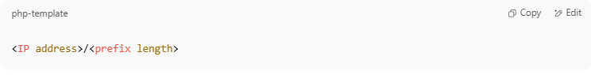
<IP address>/<prefix length>

For example:
192.168.1.0/24 — This means 256 IP addresses starting from 192.168.1.0.

🧠 Simple Definition:
# Source: Chatgpt (GPT-5-Mini) at [1/18/2026]
CIDR is a flexible way to represent a range of IP addresses by specifying how many bits are used for the network portion.

🔢 CIDR Notation Breakdown
# Source: Chatgpt (GPT-5-Mini) at [1/18/2026]
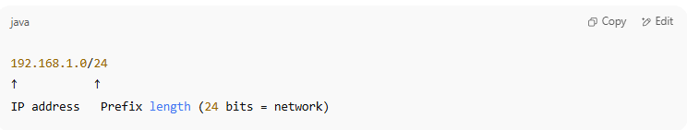
192.168.1.0/24
↑ ↑
IP address Prefix length (24 bits = network)

- The remaining 8 bits (32–24 = 8) are for host addresses.
- So:
→ 192.168.1.0 to 192.168.1.255 = 256 IPs.

🔄 Why CIDR Replaced IP Classes
# Source: Chatgpt (GPT-5-Mini) at [1/18/2026]
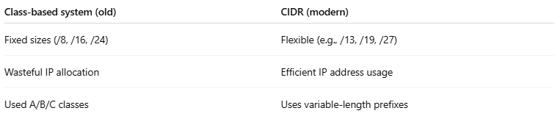
Class-based system (old) | CIDR (modern)
Fixed sizes (/8, /16, /24) | Flexible (e.g., /13, /19, /27)
Wasteful IP allocation | Efficient IP address usage
Used A/B/C classes | Uses variable-length prefixes

📦 Example CIDR Ranges
# Source: Chatgpt (GPT-5-Mini) at [1/18/2026]
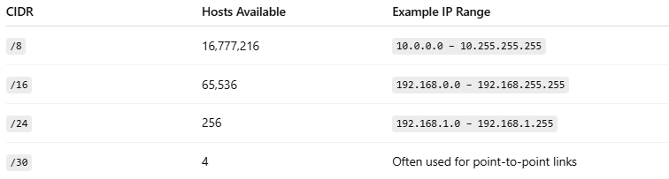
CIDR | Hosts Available | Example IP Range
/8 | 16,777,216 | 10.0.0.0 – 10.255.255.255
/16 | 65,536 | 192.168.0.0 – 192.168.255.255
/24 | 256 | 192.168.1.0 – 192.168.1.255
/30 | 4 | Often used for point-to-point links

🧭 CIDR in Routing
# Source: Chatgpt (GPT-5-Mini) at [1/18/2026]
CIDR allows routers to aggregate routes:
Example:
- Instead of advertising 8 separate routes:
  - 192.168.0.0/24, 192.168.1.0/24, ..., 192.168.7.0/24
- A router can advertise:
  - 192.168.0.0/21 — combining all 8 subnets into one supernet
This is called route summarization, reducing BGP table size.

✅ Summary
# Source: Chatgpt (GPT-5-Mini) at [1/18/2026]
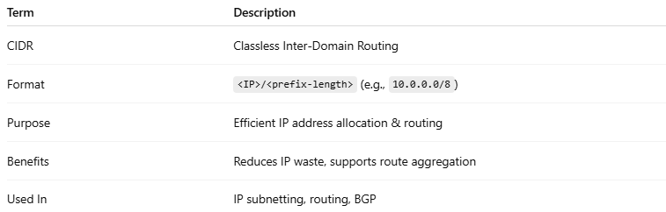
Term | Description
CIDR | Classless Inter-Domain Routing
Format | <IP>/<prefix-length> (e.g., 10.0.0.0/8)
Purpose | Efficient IP address allocation & routing
Benefits | Reduces IP waste, supports route aggregation
Used In | IP subnetting, routing, BGP

